**Name:** Espiritu, Demet B. **Course YR/Sec:** BSIT4D

**A.** **Adding Drive, Partitioning, and Formatting (Traditional file system)**

* Add 1 hard disk (SATA, Size: 10 GB)

1. A screenshot of a computer

   Description automatically generatedClick the hard disk icon to add.

* Click the Create icon.

* A screenshot of a computer

  Description automatically generatedCREATE and then choose VDI (Virtual Hard Disk)
* A screenshot of a computer

  Description automatically generatedSet the storage for 10GB. Then, Click finish.
* Choose the created storage.

* Hard disk added

* Partition into two.
* A screenshot of a computer

  Description automatically generatedPartition for ext4.
* A screenshot of a computer

  Description automatically generatedPartition for ntfs
* Format the two partitions with ext4 and ntfs respectively.

* Format the patition with nfts then apply.

* 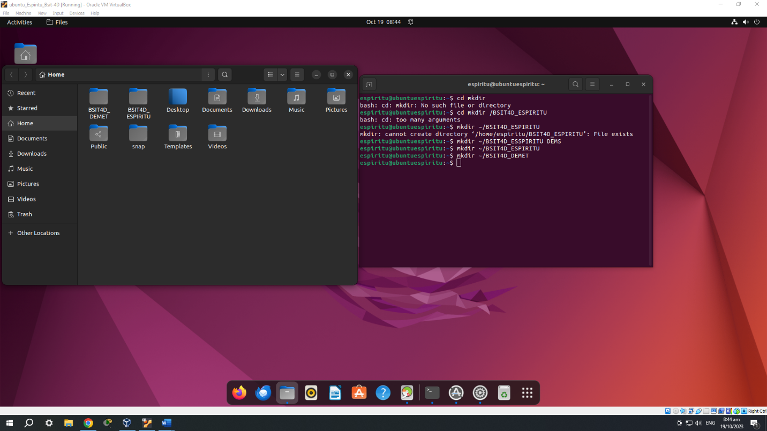Create two directories inside your home directory.
* Manually mount Partition 1 in the user-created directory inside the user’s home directory.

* In your home directory, invoke the change attribute command for the first mount point: sudo chmod 777 Ex. sudo chmod 777 BSIT4D_ESPIRITU

